**Assignment 5**

6.118

6.124

6.128

6.129

6.130

6.133

**6.118 Planning another test to compare consumption.**

A test of a hypothesis about the mean consumption of sugar- sweetened beverages at your university based on a sample of size n=100. The hypotheses are

H0:μ=286

Ha:μ≠286

While the result was not statistically significant, it did provide some evidence that the mean was smaller than 286. Thus, you plan to recruit another sample of students from your university but this time use a onesided alternative. You were thinking of surveying n=100 students but now wonder if this sample size gives adequate power to detect a decrease of 15 calories per day to μ=271.

(a) Given α=0.05, for what values of *z* will you reject the null hypothesis?

(b) Using σ=155 and μ=286 for what values of x¯ will you reject *H*0?

(c) Using σ=155 and μ=271, what is the probability that x¯ will fall in the region defined in part (b)?

(d) Will a sample size of n=100 give you adequate power? Or do you need to find ways to increase the power? Explain your answer.

(e) Use the *Statistical Power* applet to determine the sample size *n* that gives you power near 0.80

**6.124 Stress by occupation.**

As part of a study on the impact of job stress on smoking, researchers used data from the Health and Retirement Study (HRS) to collect information on 3825 ever-smoker individuals who were 50 to 64 years of age.32 An ever-smoker is someone who was a smoker at some time in his or her life. The HRS is a biennial survey, thus providing the researchers with 17,043 person-year observations. One of the questions on the survey asked a participant how much he or she agrees or disagrees with the statement “My job involves a lot of stress.” The answers were coded as a 1 if a participant “strongly agreed” and 0 otherwise. The following table summarizes these responses by occupation.

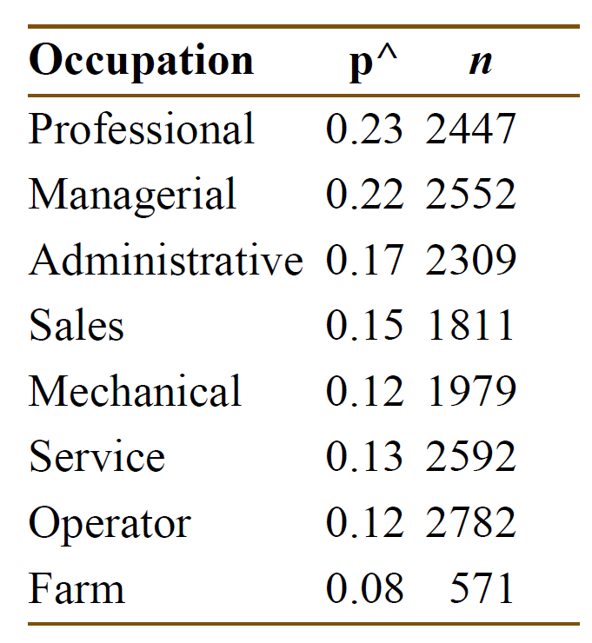

(a) Because these responses are binary, use the formula for the standard deviation of a sample

proportion (page 330) and construct 95% confidence intervals for each occupation.

(b) Summarize the results. Do there appear to be certain groups of occupations with similar stress levels?

(c) A friend questions the use of the standard deviation formula in part (a). Refer back to the

binomial setting. What might your friend be concerned with?

**6.128 Effect of sample size on significance.**

You are testing the null hypothesis that μ=0 versus the alternative μ>0 using α=0.05 Assume that σ=14. Suppose that x¯=4 and n=10 Calculate the test statistic and its *P*-value. Repeat, assuming the same value of x¯ but with n=20. Do the same for sample sizes of 30, 40, and 50. Plot the values of the test statistic versus the sample size. Do the same for the *P*-values.

Summarize what this demonstration shows about the effect of the sample size on significance testing.

**6.129 Blood phosphorus level in dialysis patients.**

Patients with chronic kidney failure may be treated by dialysis, in which a machine removes toxic wastes from the blood, a function normally performed by the kidneys. Kidney failure and dialysis can cause other changes, such as retention of phosphorus, that must be corrected by changes in diet. A study of the nutrition of dialysis patients measured the level of phosphorus in the blood of several patients on six occasions. Here are the data for one patient (in milligrams of phosphorus per deciliter of blood)

5.4 5.2 4.5 4.9 5.7 6.3

The measurements are separated in time and can be considered an SRS of the patient’s blood

phosphorus level. Assume that this level varies Normally with σ=0.9 mg/dl.

1. Give a 95% confidence interval for the mean blood phosphorus level.

(b) The normal range of phosphorus in the blood is considered to be 2.6 to 4.8 mg/dl. Is there strong evidence that this patient has a mean phosphorus level that exceeds 4.8?

**6.130 Cellulose content in alfalfa hay.**

An agronomist examines the cellulose content of a variety of alfalfa hay. Suppose that the cellulose content in the population has standard deviation σ=8 milligrams per gram (mg/g). A sample of 15 cuttings has mean cellulose content x¯=145 mg/g.

(a) Give a 90% confidence interval for the mean cellulose content in the population.

(b) A previous study claimed that the mean cellulose content was μ=140 mg/g, but the agronomist believes that the mean is higher than that figure. State *H*0 and *Ha* and carry out a significance test to see if the new data support this belief.

(c) The statistical procedures used in parts (a) and (b) are valid when several assumptions are met. What are these assumptions?

**6.133 CEO pay.**

A study of the pay of corporate chief executive officers (CEOs) examined the increase in cash

compensation of the CEOs of 104 companies, adjusted for inflation, in a recent year. The mean

increase in real compensation was x¯=6.9%, and the standard deviation of the increases was s=55%. Is this good evidence that the mean real compensation *μ* of all CEOs increased that year? The hypotheses are

H0:μ=0 (no increase)

Ha:μ>0 (an increase)

Because the sample size is large, the sample *s* is close to the population *σ*, so take σ=55%.

(a) Sketch the Normal curve for the sampling distribution of x¯ when *H*0 is true. Shade the area that represents the *P*-value for the observed outcome x¯=6.9%.

(b) Calculate the *P*-value.

(c) Is the result significant at the α=0.05 level? Do you think the study gives strong evidence that the mean compensation of all CEOs went up?